Screenshots of SQL query results of the E-commerce summary

Combines orders with customer details

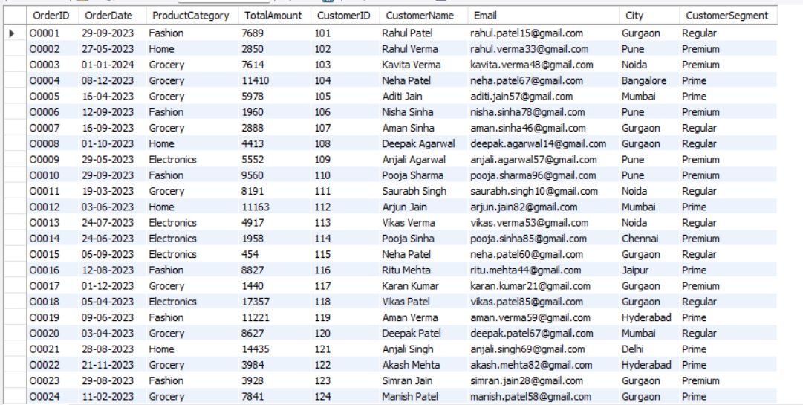

-- Revenue per SKU / product, Total units sold and Sorted highest revenue first
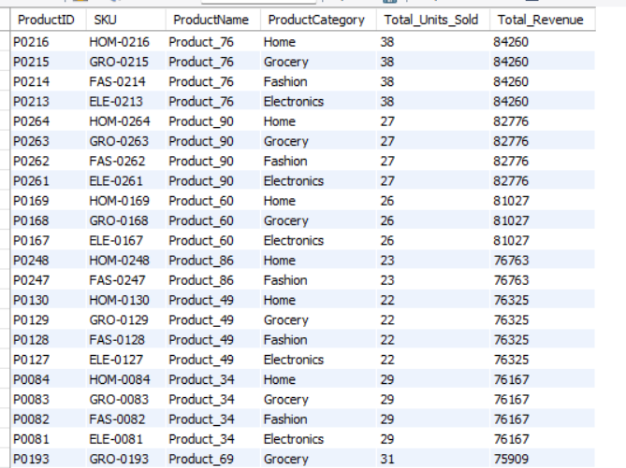

- Top 10 High Performing SKUs
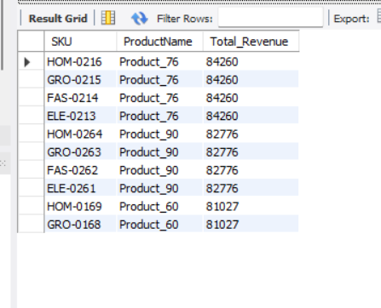

- Total revenue generated by each product category
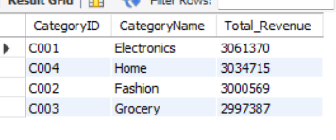

Total Sales in Mumbai From 1 Jan 2023 to 31 Mar 2023
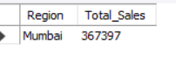

- Final Dataset(Customers, Orders, Products)
